LAPORAN UTS DATABASE

1. **solusi tabel bentuk normal pertama (1NF)**

|  |  |  |  |  |  |  |  |  |  |
| --- | --- | --- | --- | --- | --- | --- | --- | --- | --- |
| **KODE_PENGADAAN** | **TANGGAL_PENGADAAN** | **KODE_SUPPLIER** | **NAMA_SUPPLIER** | **ALAMAT_SUPPLIER** | **KODE_BARANG** | **NAMA_BARANG** | **HARGA** | **JUMLAH** | **TOTAL_HARGA** |
| PGD001 | 2024-10-15 | SUP001 | PT. ABC | Jl. Merdeka No. 1 | BRG001 | Indomie Goreng | 100000 | 10 | 1000000 |
| PGD002 | 2024-10-15 | SUP002 | PT. XYZ | Jl. Sudirman No. 20 | BRG002 | Indomie Goreng Jumbo | 200000 | 5 | 1000000 |
| PGD003 | 2024-10-16 | SUP001 | PT. ABC | Jl. Merdeka No. 1 | BRG001 | Indomie Goreng | 100000 | 5 | 500000 |
| PGD003 | 2024-10-16 | SUP001 | PT. ABC | Jl. Merdeka No. 1 | BRG003 | Mie Sedaap Goreng | 100000 | 7 | 700000 |

1. **solusi tabel bentuk normal kedua (2NF)**
2. **Tabel Supplier**

|  |  |  |
| --- | --- | --- |
| **KODE_SUPPLIER** | **NAMA_SUPPLIER** | **ALAMAT_SUPPLIER** |
| SUP001 | PT. ABC | Jl. Merdeka No. 1 |
| SUP002 | PT. XYZ | Jl. Sudirman No. 20 |

1. **Tabel Pengadaan**

|  |  |  |
| --- | --- | --- |
| **KODE_PENGADAAN** | **TANGGAL_PENGADAAN** | **KODE_SUPPLIER** |
| PGD001 | 2024-10-15 | SUP001 |
| PGD002 | 2024-10-15 | SUP002 |
| PGD003 | 2024-10-16 | SUP001 |

1. **Tabel Detail Pengadaan**

|  |  |  |  |  |  |
| --- | --- | --- | --- | --- | --- |
| **KODE_PENGADAAN** | **KODE_BARANG** | **NAMA_BARANG** | **HARGA** | **JUMLAH** | **TOTAL_HARGA** |
| PGD001 | BRG001 | Indomie Goreng | 100000 | 10 | 1000000 |
| PGD002 | BRG002 | Indomie Goreng Jumbo | 200000 | 5 | 1000000 |
| PGD003 | BRG001 | Indomie Goreng | 100000 | 5 | 500000 |
| PGD003 | BRG003 | Mie Sedaap Goreng | 100000 | 7 | 700000 |

1. **solusi tabel bentuk normal ketiga (3NF) + Bentuk normal Boyce-Codd**
   1. **Tabel Supplier**

|  |  |  |
| --- | --- | --- |
| **KODE_SUPPLIER** | **NAMA_SUPPLIER** | **ALAMAT_SUPPLIER** |
| SUP001 | PT. ABC | Jl. Merdeka No. 1 |
| SUP002 | PT. XYZ | Jl. Sudirman No. 20 |

* 1. **Tabel Pengadaan**

|  |  |  |
| --- | --- | --- |
| **KODE_PENGADAAN** | **TANGGAL_PENGADAAN** | **KODE_SUPPLIER** |
| PGD001 | 2024-10-15 | SUP001 |
| PGD002 | 2024-10-15 | SUP002 |
| PGD003 | 2024-10-16 | SUP001 |

* 1. **Tabel Barang**

|  |  |  |
| --- | --- | --- |
| **KODE_BARANG** | **NAMA_BARANG** | **HARGA** |
| BRG001 | Indomie Goreng | 100000 |
| BRG002 | Indomie Goreng Jumbo | 200000 |
| BRG003 | Mie Sedaap Goreng | 100000 |

* 1. **Tabel Detail Pengadaan**

|  |  |  |  |
| --- | --- | --- | --- |
| **KODE_PENGADAAN** | **KODE_BARANG** | **JUMLAH** | **TOTAL_HARGA** |
| PGD001 | BRG001 | 10 | 1000000 |
| PGD002 | BRG002 | 5 | 1000000 |
| PGD003 | BRG001 | 5 | 500000 |
| PGD003 | BRG003 | 7 | 700000 |

1. **Primaty Key dan Foreign Key**
2. **Tabel: Supplier**

|  |  |  |
| --- | --- | --- |
| **Kolom** | **Tipe Data** | **Keterangan** |
| kode_supplier | VARCHAR(10) | Primary Key |
| nama_supplier | VARCHAR(50) | Nama supplier |
| alamat_supplier | VARCHAR(100) | Alamat lengkap supplier |

1. **Tabel: Barang**

|  |  |  |
| --- | --- | --- |
| **Kolom** | **Tipe Data** | **Keterangan** |
| kode_barang | VARCHAR(10) | Primary Key |
| nama_barang | VARCHAR(50) | Nama barang |
| harga | INT | Harga satuan barang |

1. **Tabel: Pengadaan**

|  |  |  |
| --- | --- | --- |
| **Kolom** | **Tipe Data** | **Keterangan** |
| kode_pengadaan | VARCHAR(10) | Primary Key |
| tanggal_pengadaan | DATE | Tanggal pengadaan barang |
| kode_supplier | VARCHAR(10) | Foreign Key ke Supplier |

1. **Tabel: Pengadaan_Detail**

|  |  |  |
| --- | --- | --- |
| **Kolom** | **Tipe Data** | **Keterangan** |
| kode_pengadaan | VARCHAR(10) | Foreign Key ke Pengadaan |
| kode_barang | VARCHAR(10) | Foreign Key ke Barang |
| jumlah | INT | Jumlah barang yang dibeli |
| total_harga | INT | Total harga untuk jumlah barang |

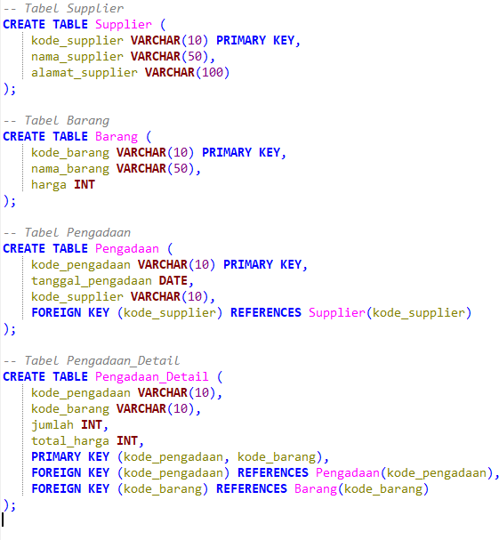

1. **eksekusi SQL Query (DML)**

**Tabel: Supplier**

|  |  |  |
| --- | --- | --- |
| **kode_supplier** | **nama_supplier** | **alamat_supplier** |
| SUP001 | PT. ABC | Jl. Merdeka No. 1 |
| SUP002 | PT. XYZ | Jl. Sudirman No. 20 |

1. **Tabel: Barang**

|  |  |  |
| --- | --- | --- |
| **kode_barang** | **nama_barang** | **harga** |
| BRG001 | Indomie Goreng | 100000 |
| BRG002 | Indomie Goreng Jumbo | 200000 |
| BRG003 | Mie Sedaap Goreng | 100000 |

1. **Tabel: Pengadaan**

|  |  |  |
| --- | --- | --- |
| **kode_pengadaan** | **tanggal_pengadaan** | **kode_supplier** |
| PGD001 | 2024-10-15 | SUP001 |
| PGD002 | 2024-10-15 | SUP002 |
| PGD003 | 2024-10-16 | SUP001 |

1. **Tabel: Pengadaan_Detail**

|  |  |  |  |
| --- | --- | --- | --- |
| **kode_pengadaan** | **kode_barang** | **jumlah** | **total_harga** |
| PGD001 | BRG001 | 10 | 1000000 |
| PGD002 | BRG002 | 5 | 1000000 |
| PGD003 | BRG001 | 8 | 800000 |
| PGD003 | BRG003 | 4 | 400000 |

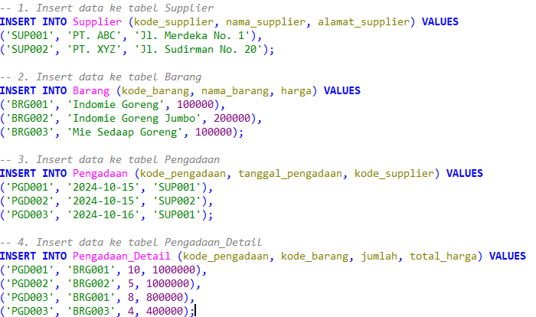

6. Joins Query

|  |  |  |  |  |  |  |  |  |  |
| --- | --- | --- | --- | --- | --- | --- | --- | --- | --- |
| **Kode_pengad aan** | **Tgl_pengad aan** | **Kode_suppl ier** | **Nama_suppl ier** | **Alamat_Supp lier** | **Kode_bara ng** | **nama_bara ng** | **qt y** | **harga_satu an** | **total_har ga** |
| PGD002 | 2024-10-15 | SUP002 | PT. XYZ | Jl. Sudirman No. 20 | BRG002 | Indomie Goreng  Jumbo | 5 | 200000 | 1000000 |

